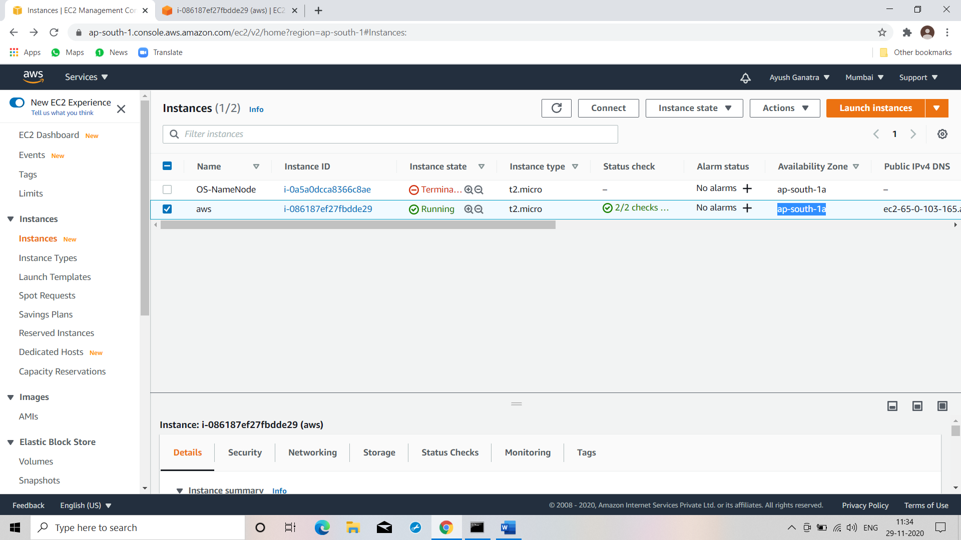

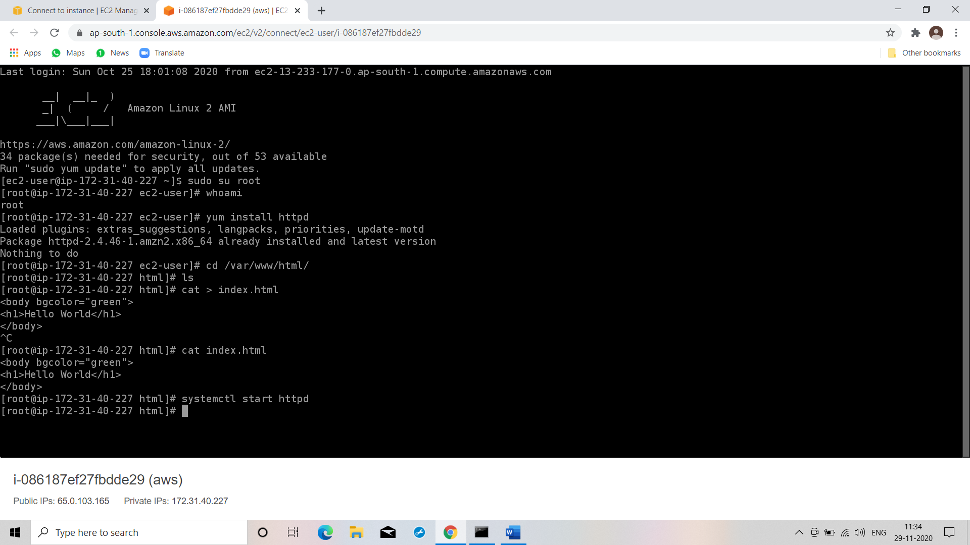

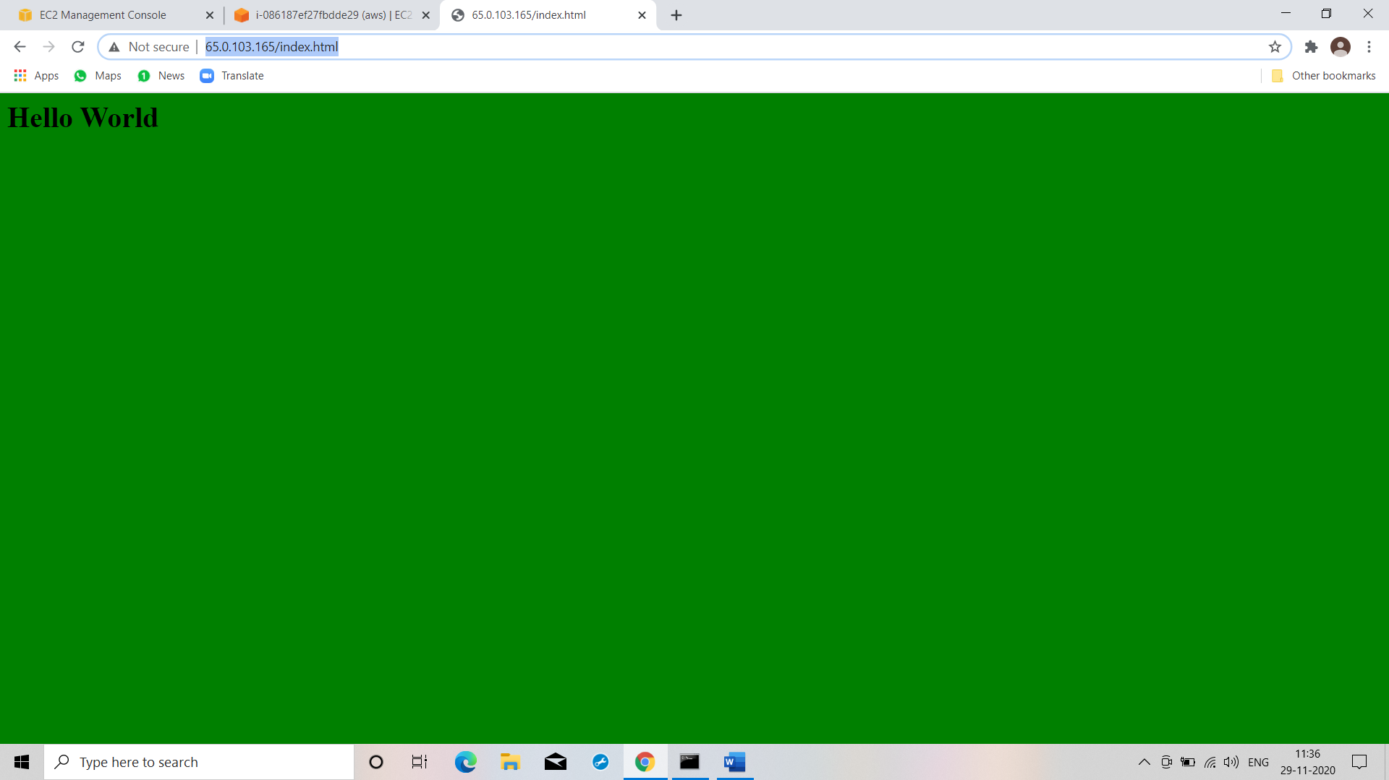

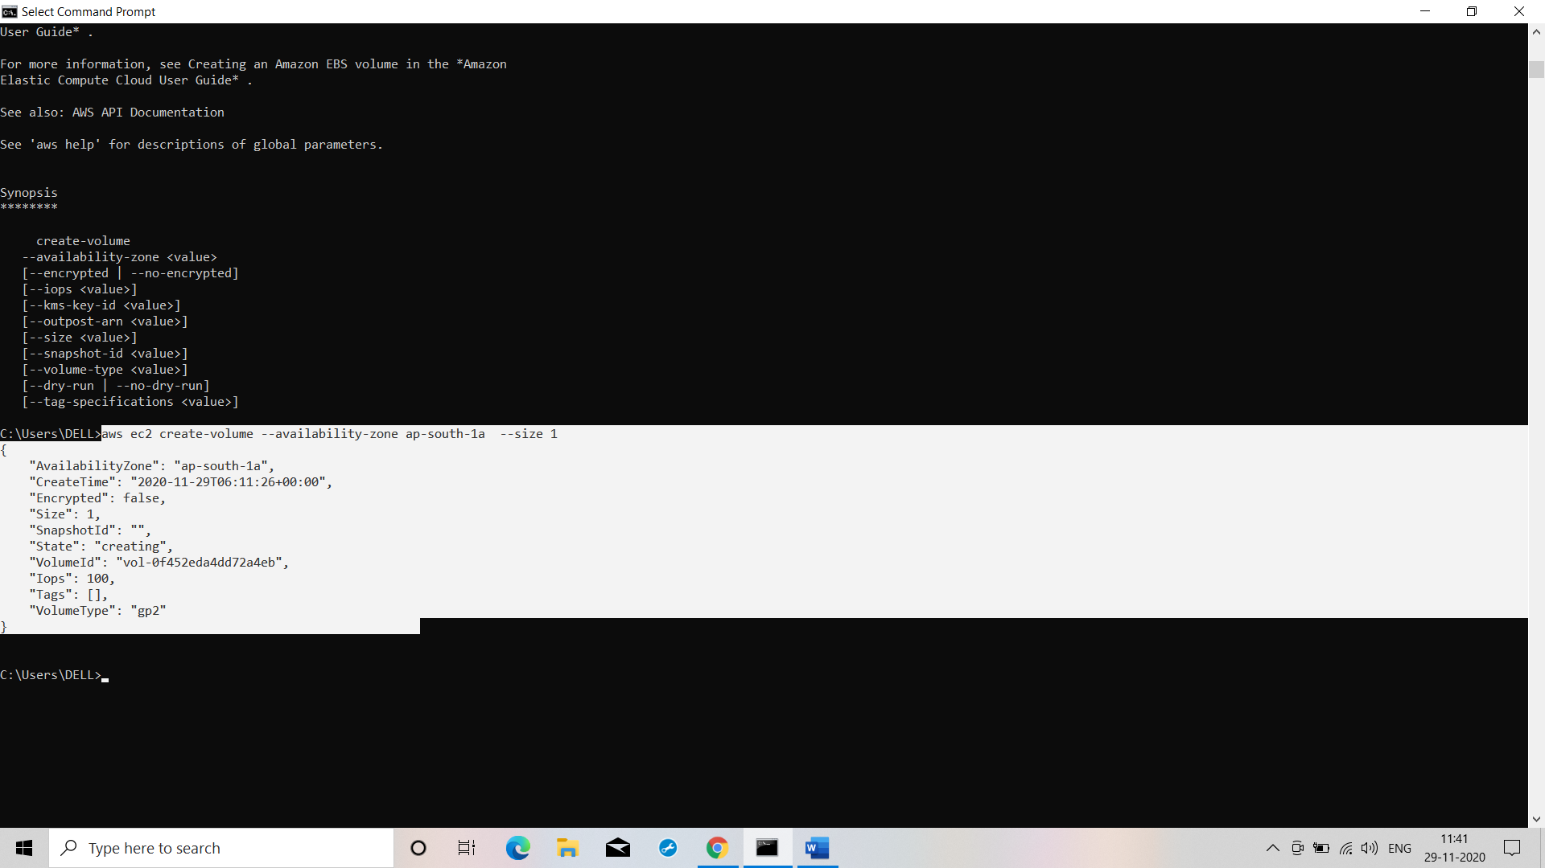

**Command: aws ec2 create-volume --availability-zone ap-south-1a --size 1**

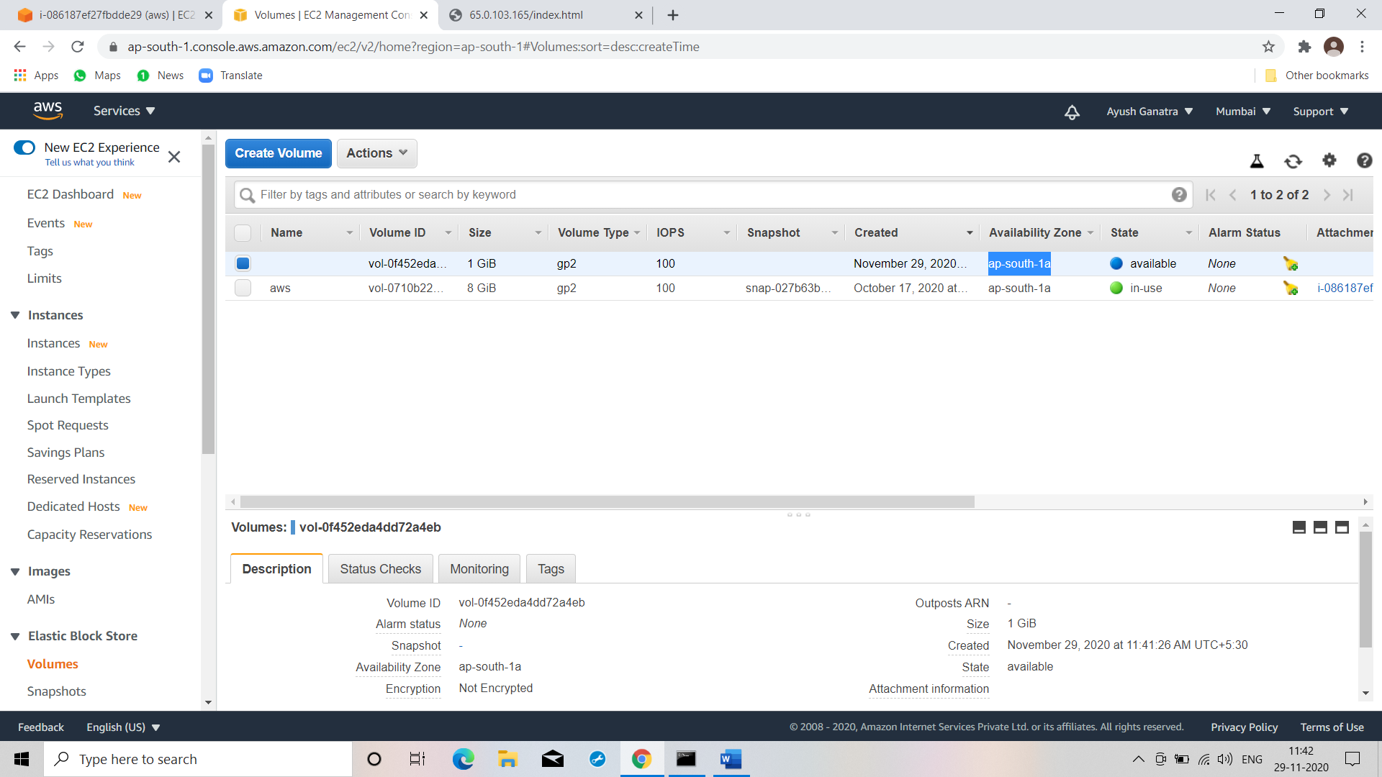

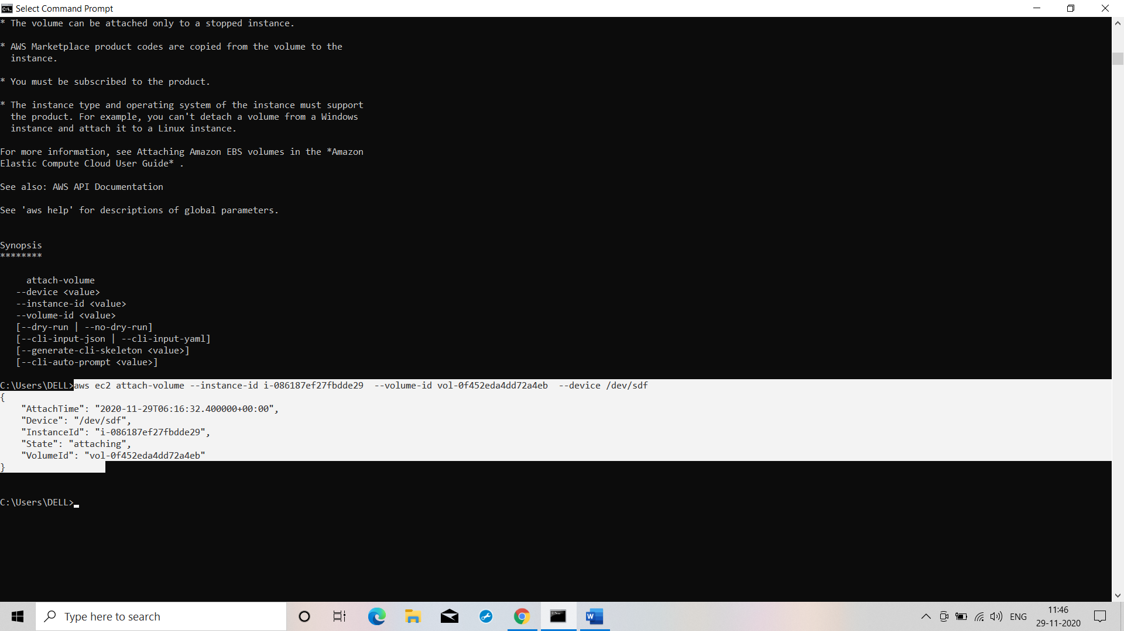

**Command : aws ec2 attach-volume --instance-id i-086187ef27fbdde29 --volume-id vol-0f452eda4dd72a4eb --device /dev/sdf**

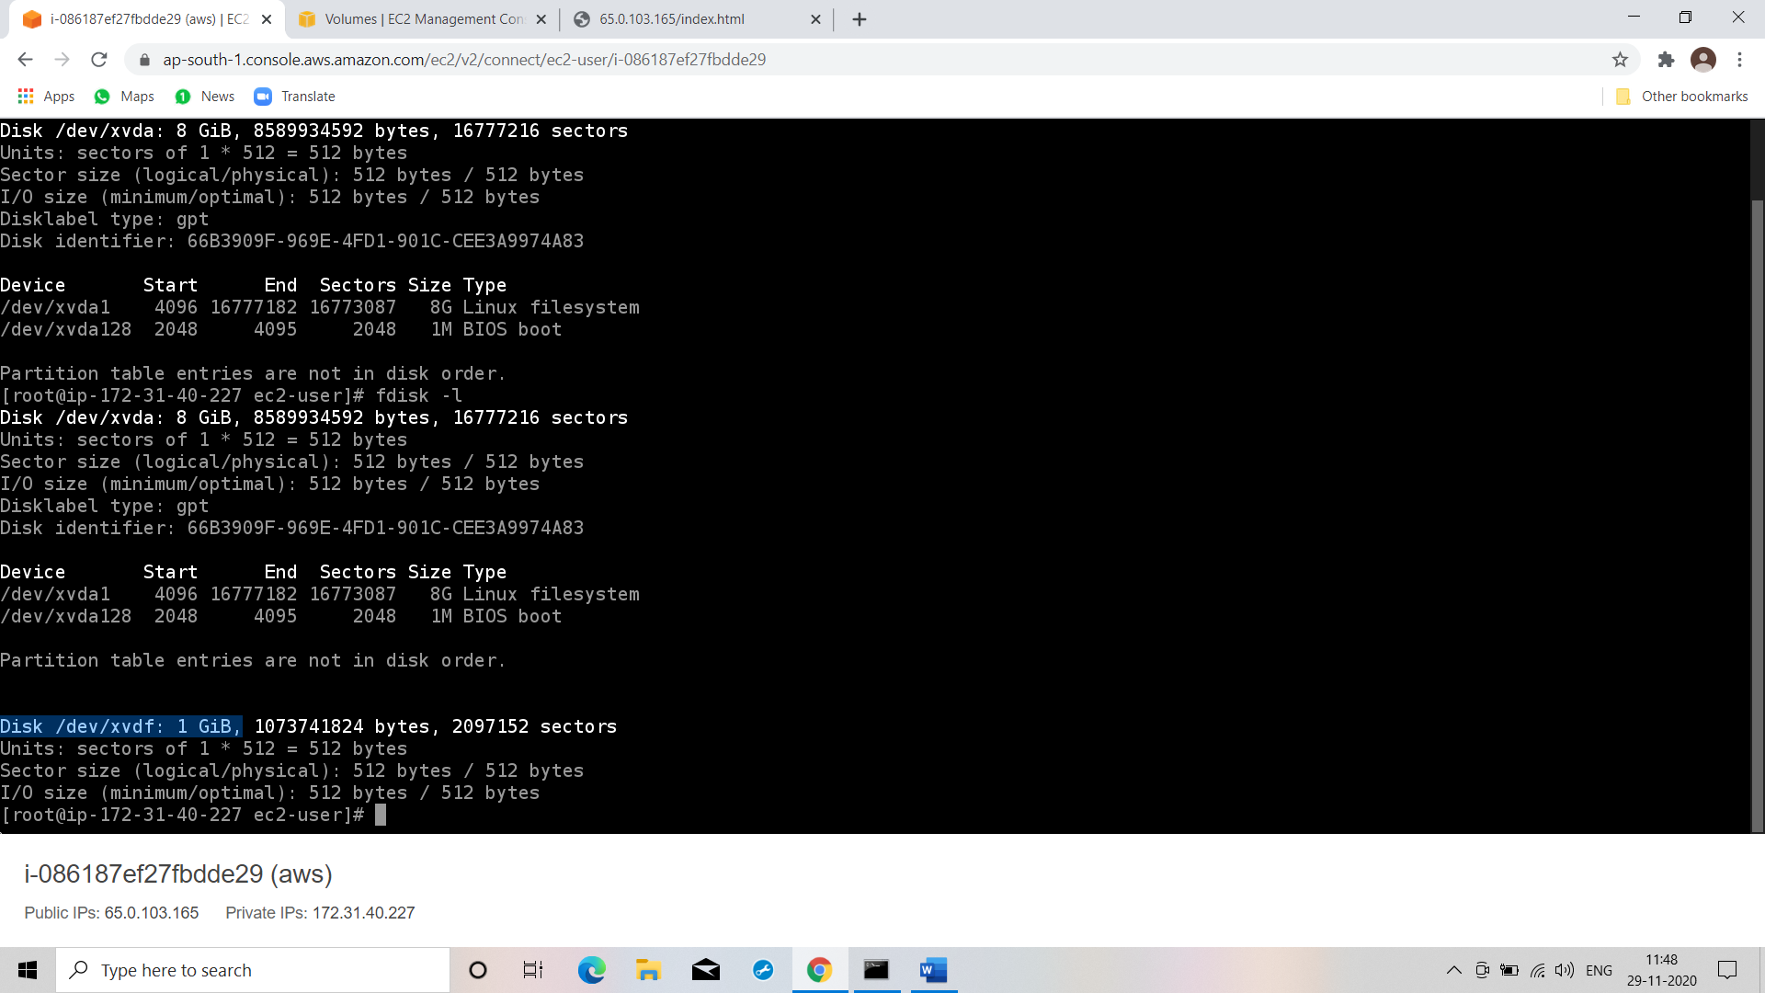

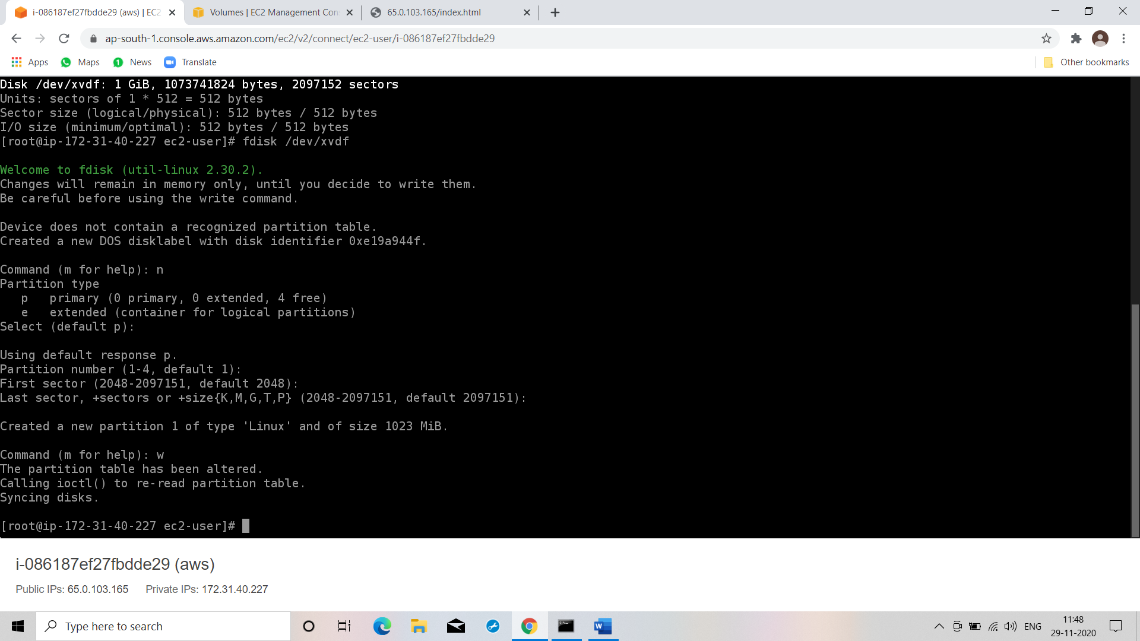

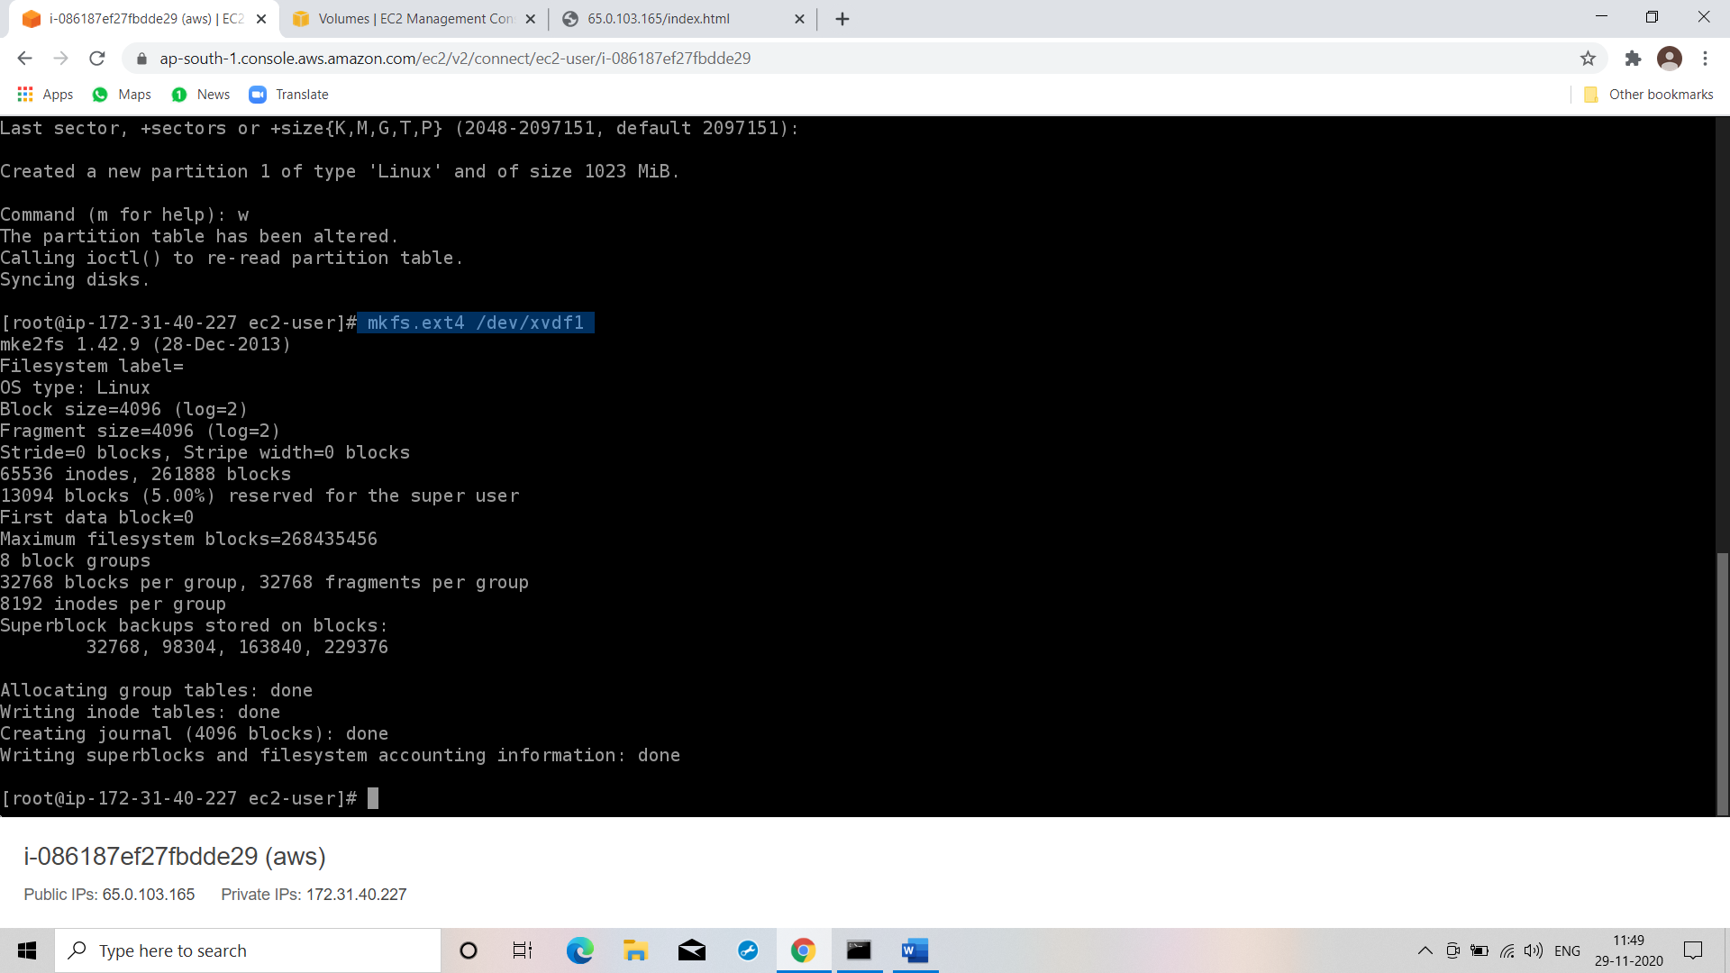

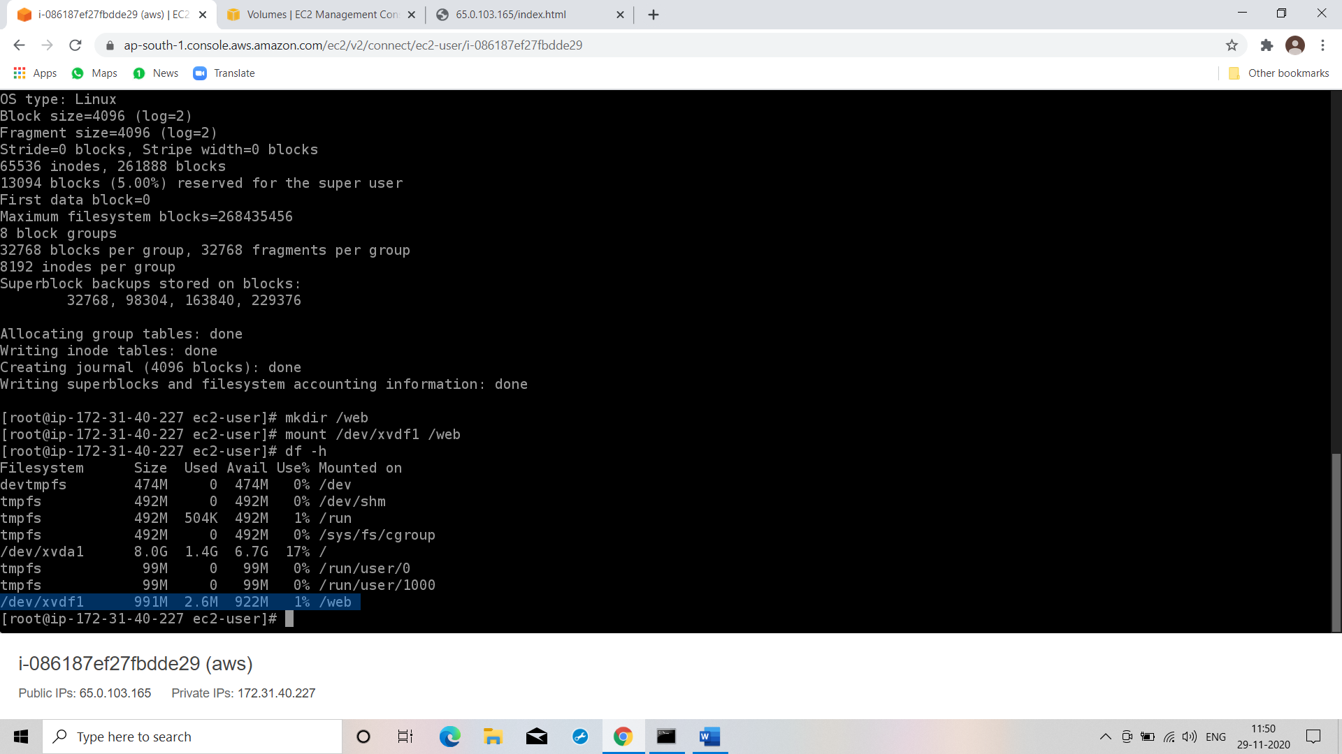

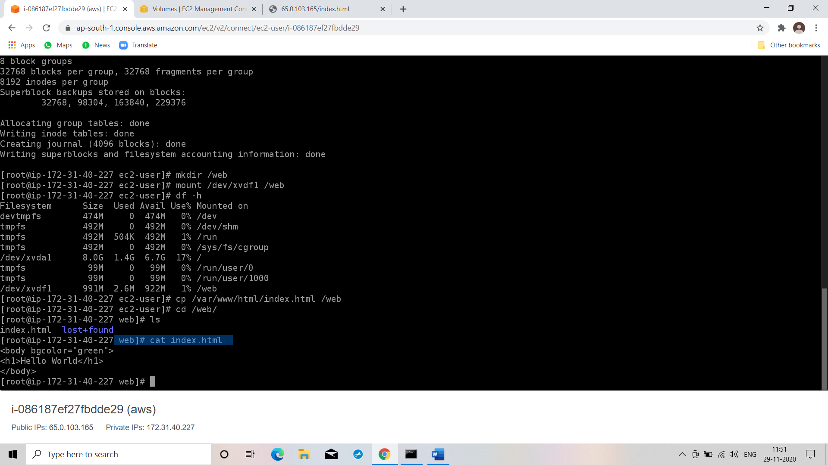

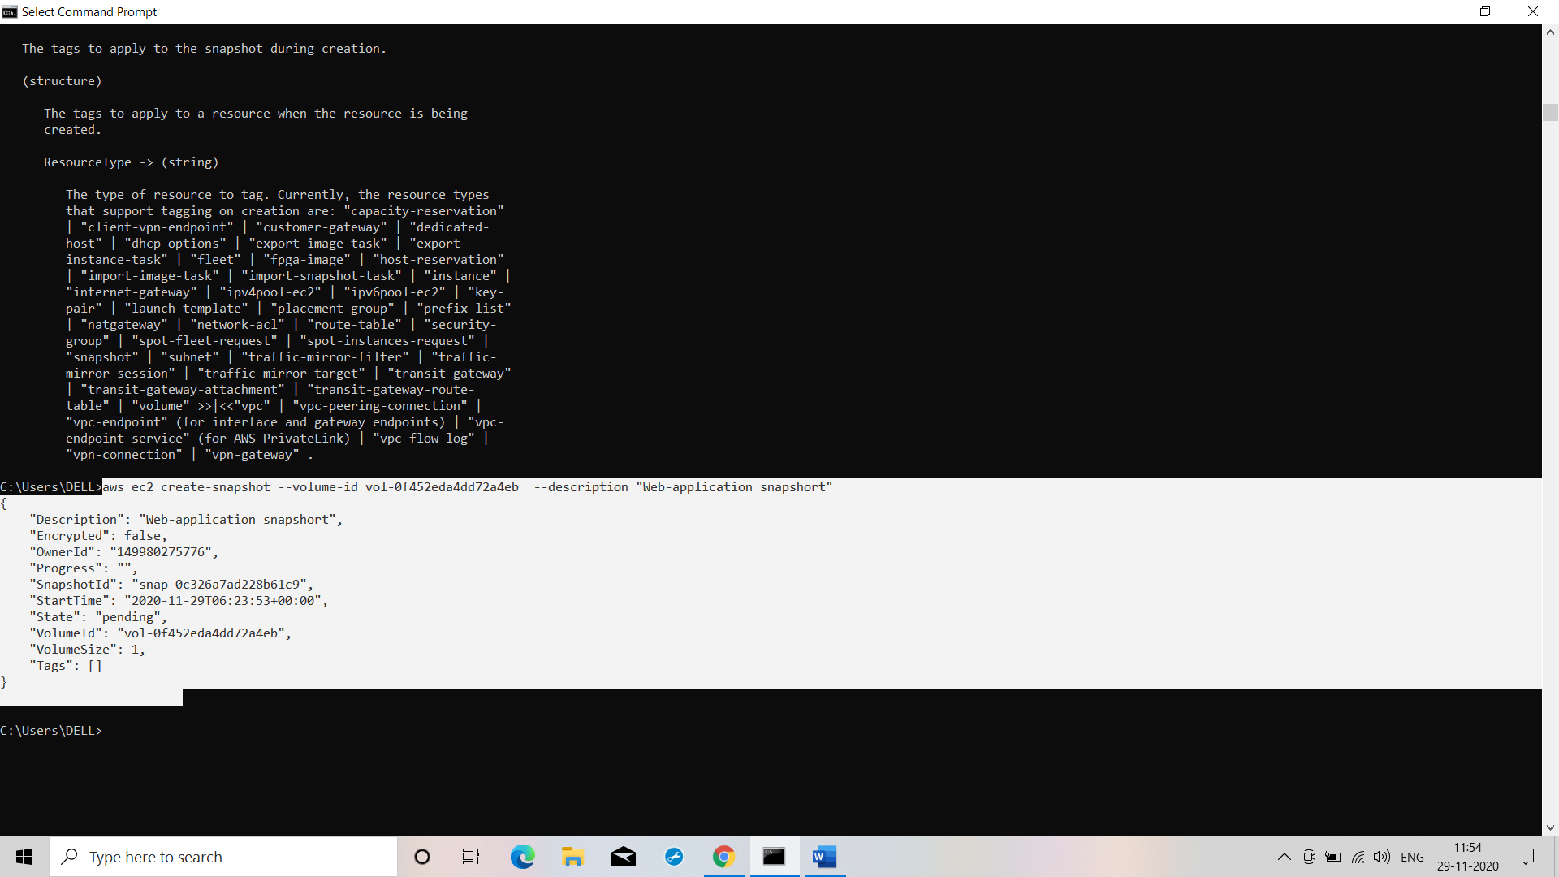

**Command : aws ec2 create-snapshot --volume-id vol-0f452eda4dd72a4eb --description "Web-application snapshort"**

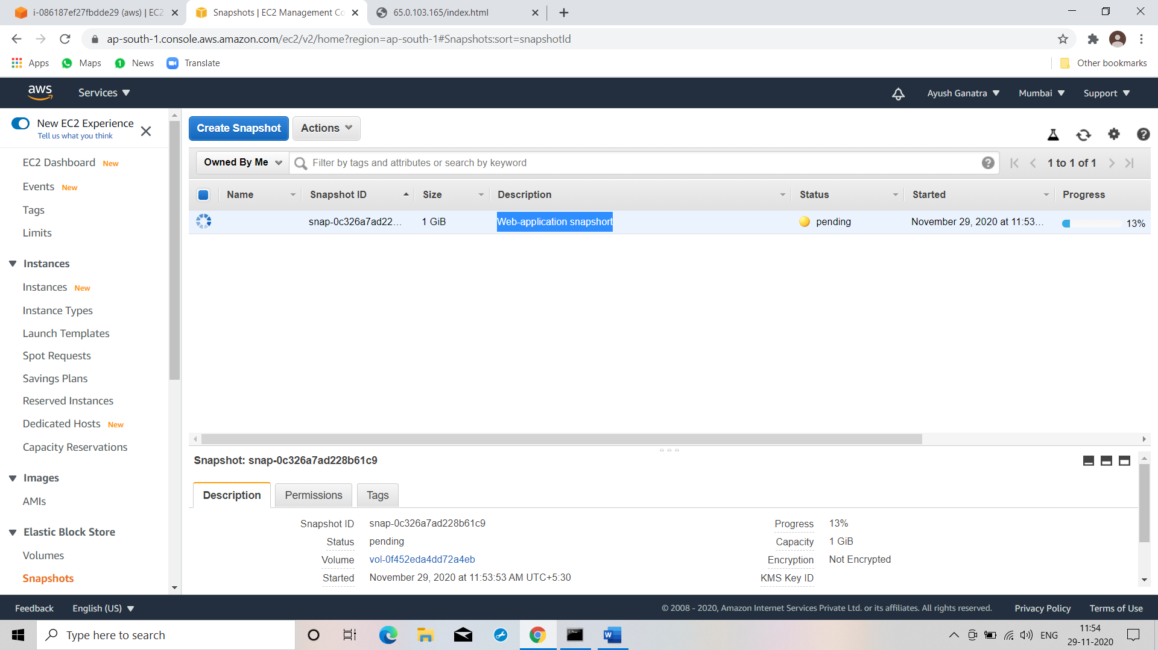

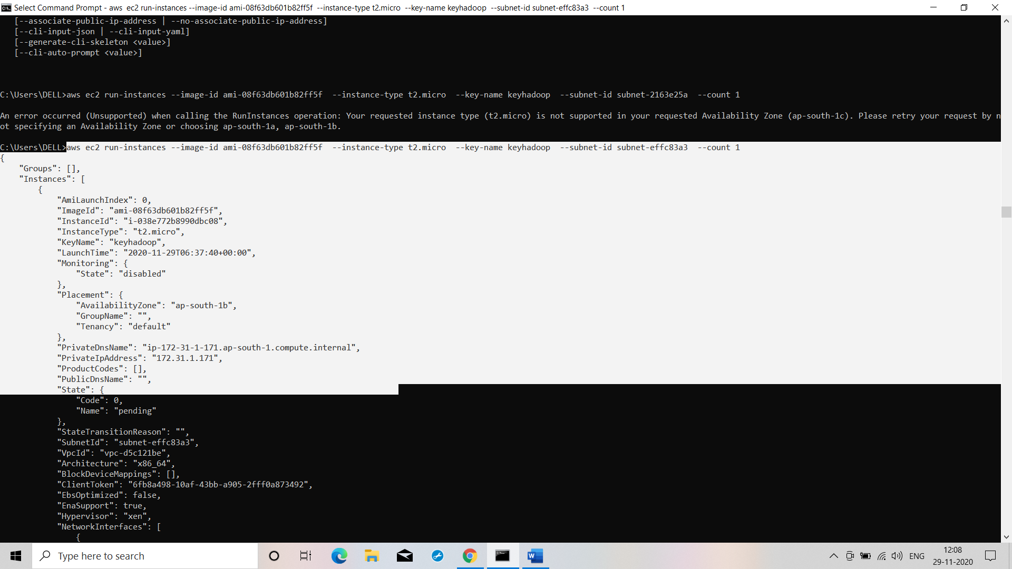

**Command: aws ec2 run-instances --image-id ami-08f63db601b82ff5f --instance-type t2.micro --key-name keyhadoop --subnet-id subnet-2163e25a --count 1**

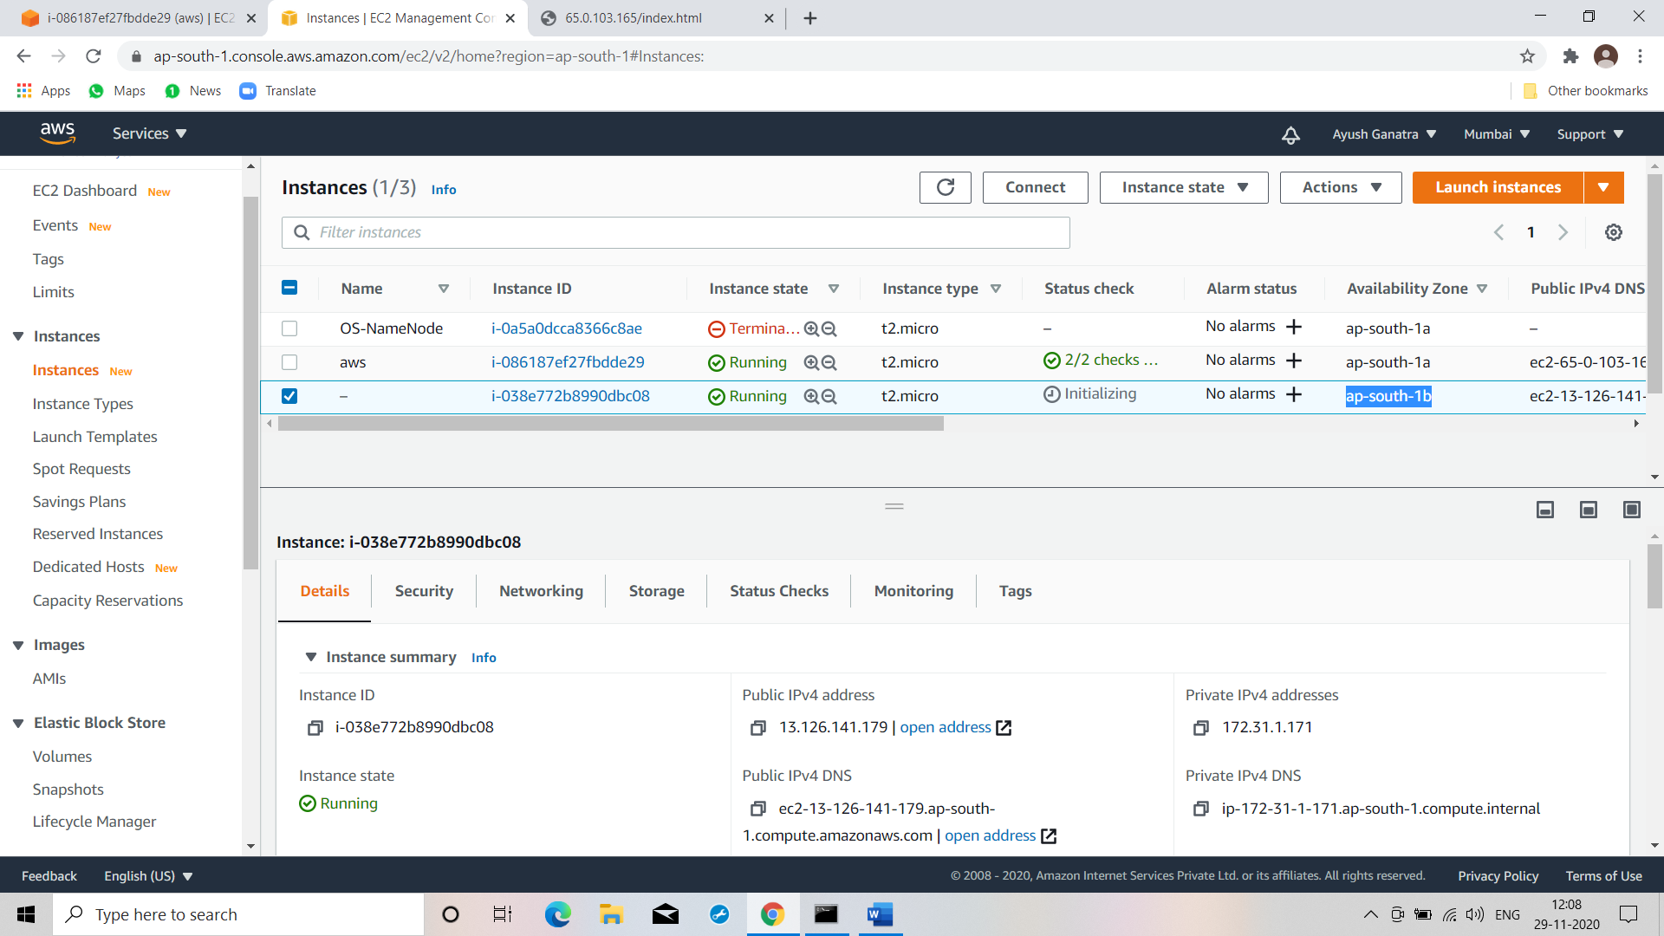

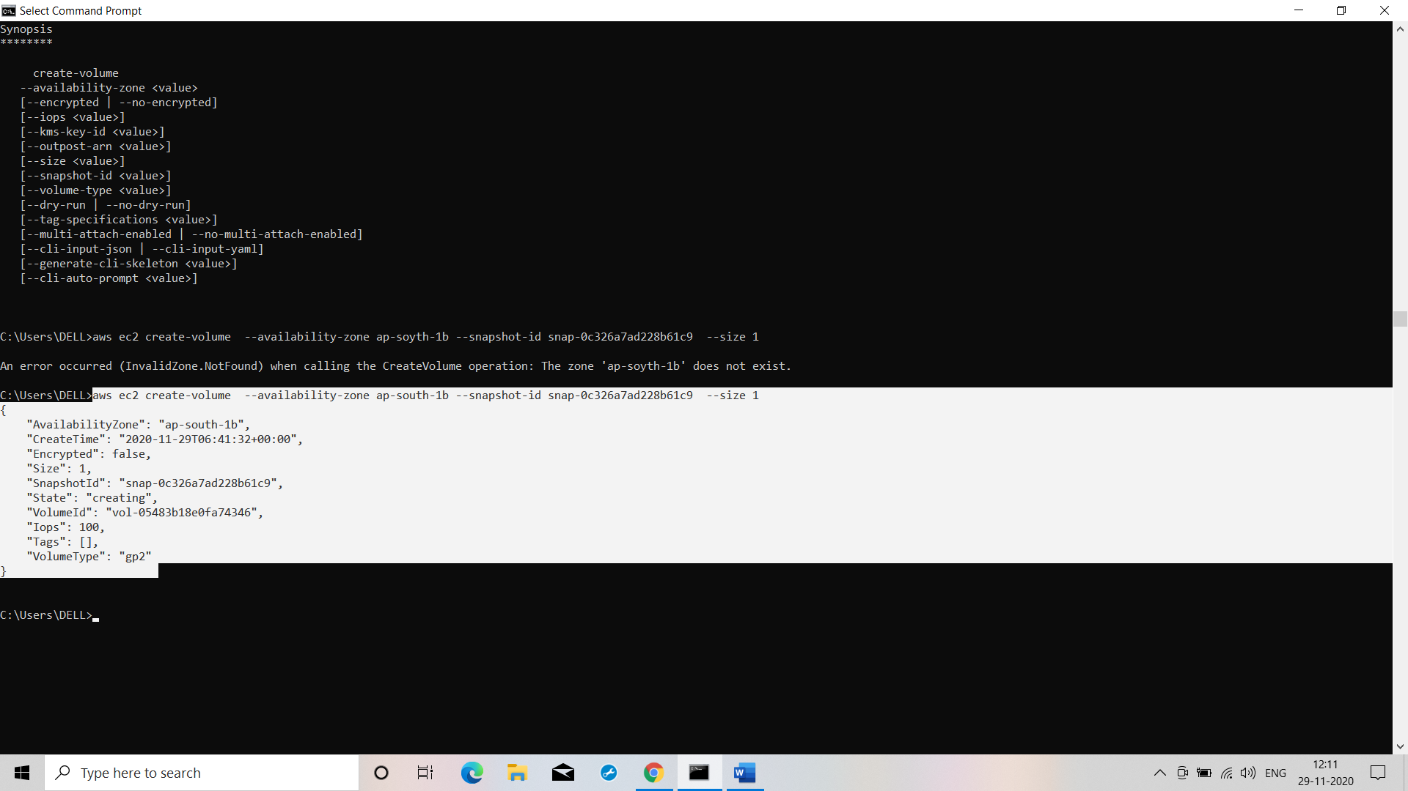

**Command: aws ec2 create-volume --availability-zone ap-south-1b --snapshot-id snap-0c326a7ad228b61c9 --size 1**

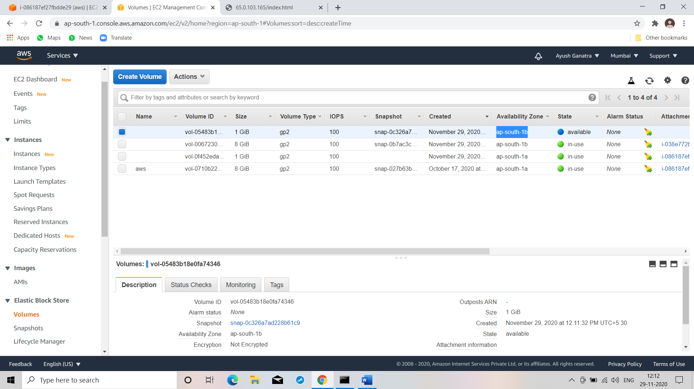

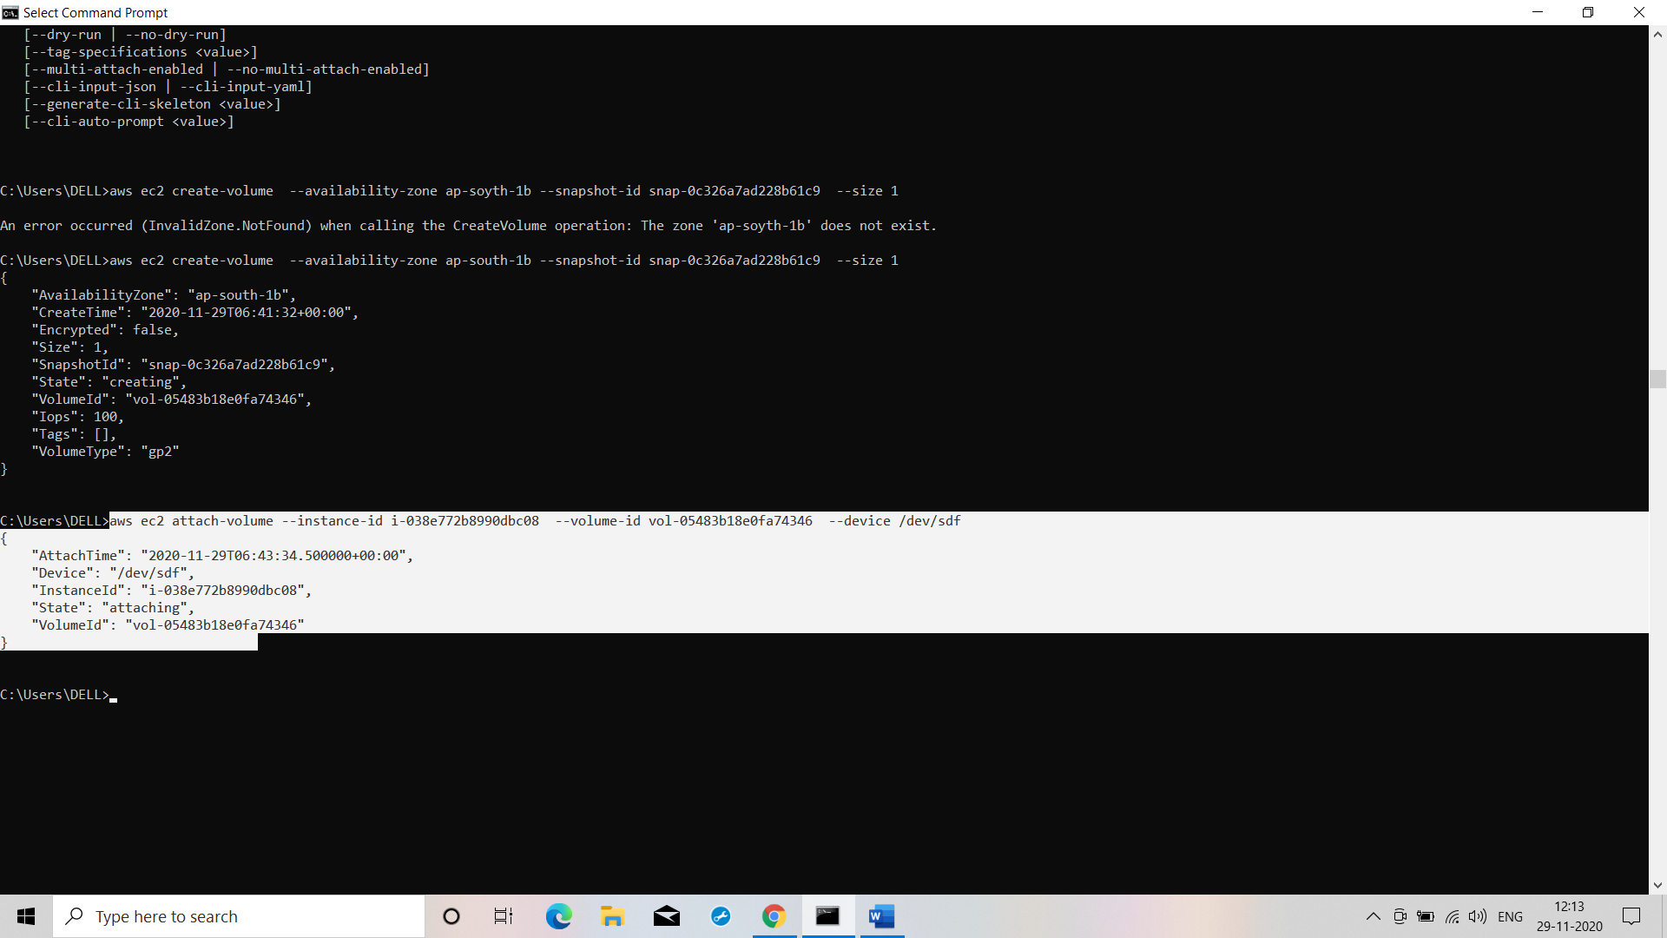

**Commandd: aws ec2 attach-volume --instance-id i-038e772b8990dbc08 --volume-id vol-05483b18e0fa74346 --device /dev/sdf**

